Oracle® Spatial User's Guide and Reference 10g Release 1 (10.1)

Part Number B10826-01 12 Spatial Operators
Svarīgākie telpiskie (spatial) operatori
Operators | Skaidrojums
SDO_FILTER | Atlasa ģeometrijas, kuras kaut kādā veidā ir saistītas ar norādīto ģeometriju.
SDO_JOIN | Veic telpisko savienojumu, balstotie uz norādi par ģeometriju saistības tipu.
SDO_NN | Nosaka tuvākās kaimiņ-ģeometrijas norādītajai ģeomerijai.
SDO_NN_DISTANCE | Nosaka attālumu līdz objektiem, kurus ieguvis SDO_NN operators.
SDO_RELATE | Nosaka vai divas ģeometrijas noteiktā veidā ir saistītas.
SDO_WITHIN_DISTANCE | Nosaka vai divas ģeometrijas ir noteiktā attālumā viena no otras.

Specializēti (ērtāki) operatori SDO_RELATE operatora darbību veikšanai
Operator | Description
SDO_ANYINTERACT | Checks if any geometries have the ANYINTERACT topological relationship with a specified geometry.
SDO_CONTAINS | Checks if any geometries in a table have the CONTAINS topological relationship with a specified geometry.
SDO_COVEREDBY | Checks if any geometries have the COVEREDBY topological relationship with a specified geometry.
SDO_COVERS | Checks if any geometries in a table have the COVERS topological relationship with a specified geometry.
SDO_EQUAL | Checks if any geometries in a table have the EQUAL topological relationship with a specified geometry.
SDO_INSIDE | Checks if any geometries in a table have the INSIDE topological relationship with a specified geometry.
SDO_ON | Checks if any geometries in a table have the ON topological relationship with a specified geometry.
SDO_OVERLAPBDYDISJOINT | Checks if any geometries in a table have the OVERLAPBDYDISJOINT topological relationship with a specified geometry.
SDO_OVERLAPBDYINTERSECT | Checks if any geometries in a table have the OVERLAPBDYINTERSECT topological relationship with a specified geometry.
SDO_OVERLAPS | Checks if any geometries in a table overlap ( OVERLAPBDYDISJOINT or OVERLAPBDYINTERSECT ) a specified geometry.
SDO_TOUCH | Checks if any geometries in a table have the TOUCH topological relationship with a specified geometry.
Ģeometriju attiecību noteikšanas modelis

Lai noteiktu attiecības starp ģeometrijām tiek lietots 9 krustojumu (intersection) modelis. Katrai ģeometrijai izdala:
- iekšieni (interior);
- robežu (boundary). Līnijām robeža ir beigu punkti.
- ārieni (exterior).

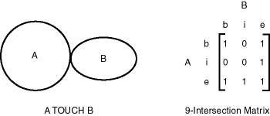
Rezultāts: 101001111
Ģeometriju topoloģiskās attiecības
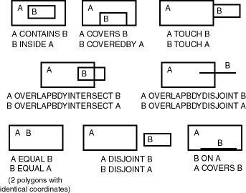
Oracle Spatial izmanto sekojošas ģeometriju telpiskās attiecības:
- DISJOINT – robežas un iekšienes nekrustojas.
- TOUCH – robežas krustojas, bet iekšienes nē.
- OVERLAPBDYDISJOINT -- The interior of one object intersects the boundary and interior of the other object, but the two boundaries do not intersect. This relationship occurs, for example, when a line originates outside a polygon and ends inside that polygon.
- OVERLAPBDYINTERSECT – divu ģeometriju robežas un iekšienes krustojas.
- EQUAL – divām ģeometrijām ir vienādas robežas un iekšienes.
- CONTAINS – vienas ģeometrijas robeža un iekšiene pilnībā ietilpst otrā.
- COVERS – vienas ģeometrijas iešiene un robeža pilnība ietilpst otrā, bet robežas saskaras.
- INSIDE – pretēji CONTAINS.
- COVEREDBY – pretēji COVERS.
- ON -- The interior and boundary of one object is on the boundary of the other object (and the second object covers the first object). This relationship occurs, for example, when a line is on the boundary of a polygon.
- ANYINTERACT – objekti kaut kādā veidā krustojas..

Primārā filtra operators SDO_FILTER

SDO_FILTER(Geometrija_, Geomerija_2);

Operators nosaka vai ģeometrijas ir saistītas ar noteiktu telpas apgabalu (tas tiek definēts arī ar ģeometriju).

SDO_FILTER parametri | Apraksts
Geometrija_1 | Specifies a geometry column in a table. The column must be spatially indexed. Data type is SDO_GEOMETRY.
Geometrija_2 | Specifies either a geometry from a table or a transient instance of a geometry. (Specified using a bind variable or SDO_GEOMETRY constructor.) Data type is SDO_GEOMETRY.

SDO_FILTER(Geometrija_1,Geometrija_2) = 'TRUE'

Geometrija_2 can come from a table or be a transient SDO_GEOMETRY object (such as a bind variable or SDO_GEOMETRY constructor).
- If the Geometrija_2 column is not spatially indexed, the operator indexes the query window in memory and performance is very good.
- If the Geometrija_2 column is spatially indexed with the same SDO_LEVEL value as the geometry1 column, the operator reuses the existing index, and performance is very good or better.
- If the Geometrija_2 column is spatially indexed with a different SDO_LEVEL value than the geometry1 column, the operator reindexes geometry2 in the same way as if there were no index on the column originally, and then performance is very good.
- If two or more geometries from Geometrija_2 are passed to the operator, the ORDERED optimizer hint must be specified, and the table in geometry2 must be specified first in the FROM clause.
In previous releases, the SDO_FILTER operator required a third parameter.
Piemēri primārajam filtram SDO_FILTER

1. Veikt ģeometriju atlasi, kurām vizmaz kāda daļa ietilpst atlases logā (4,6) , (8,8).
SELECT C.NUM, C.NOS
FROM Slanis_1 C
WHERE SDO_FILTER(C.GEOMETRIJA, SDO_GEOMETRY(2003, NULL,
NULL, SDO_ELEM_INFO_ARRAY(1,1003,3),
SDO_ORDINATE_ARRAY(4,6, 8,8)) ) = 'TRUE';
C.NUM C.NOS
--------------------------------------
5 Ģeometrija 5
7 Ģeometrija 7

2. Veikt ģeometriju atlasi no tabulas Slanis_1, kuras jebkurā veidā ir saistīas ar tabulas Slanis_2 ģeometriju G1.

SELECT A.NOS
FROM Slanis_1 A, Slanis_2 B
WHERE B.NOS = ‘G1’ AND SDO_FILTER(A.GEOMETRIJA,
B.GEOMETRIJA) = 'TRUE';

3. Veikt ģeometriju atlasi no tabulas Slanis_1, kuras jebkurā veidā ir saistīas ar ģeometriju, kas tiek glabāta mainīgajā a_geom.

SELECT A.NOS
FROM Slanis_1 A
WHERE SDO_FILTER(A.GEOMETRIJA, :a_geom) = 'TRUE';

4. Veikt ģeometriju atlasi no tabulas Slanis_1, kuras jebkurā veidā ir saistīas ar ģeometriju, kas definēta lietojot konstruktora funkciju sdo_geom.

SELECT A.NOS
FROM Slanis_1 A
WHERE SDO_FILTER(A.GEOMETRIJA, sdo_geometry(2003,NULL,
NULL, sdo_elem_info_array(1,1003,3),
sdo_ordinate_array(x1,y1,x2,y2)) ) = 'TRUE';

5. Veikt ģeometriju atlasi no tabulas Slanis_1, kuras jebkurā veidā ir saistīas ar ģeometrijām tabulā Slanis_2.

SELECT /*+ ORDERED */ A.NOS
FROM Slanis_2 B, Slanis_1 A
WHERE SDO_FILTER(A.GEOMETRIJA, B.GEOMETRIJA) = 'TRUE';

Primārā un sekundārā filtra operators SDO_RELATE

SDO_RELATE(Geometrija_1, Geometrija_2, oper_parametri);

Uses the spatial index to identify either the spatial objects that have a particular spatial interaction with a given object such as an area of interest, or pairs of spatial objects that have a particular spatial interaction. This operator performs both primary and secondary filter operations.

SDO_RELATE parametri | Apraksts
Geometrija_1 | Specifies a geometry column in a table. The column must be spatially indexed. Data type is SDO_GEOMETRY.
Geometrija_2 | Specifies either a geometry from a table or a transient instance of a geometry. (Specified using a bind variable or SDO_GEOMETRY constructor.) Data type is SDO_GEOMETRY.
oper_parametri | Uses the mask keyword to specify the topological relationship of interest. This is a required parameter. Data type is VARCHAR2.  Valid mask keyword values are one or more of the following in the nine-intersection pattern: TOUCH, OVERLAPBDYDISJOINT, OVERLAPBDYINTERSECT, EQUAL, INSIDE, COVEREDBY, CONTAINS, COVERS, ANYINTERACT, ON. Multiple masks are combined with the logical Boolean operator OR, for example, 'mask=inside+touch'; however, see the Usage Notes for an alternative syntax using UNION ALL that may result in better performance.  For backward compatibility, any additional keywords for the param parameter that were supported in the previous release will still work; however, the use of those keywords is discouraged and is not supported for new uses of the operator.

SDO_RELATE(Geometrija_1, Geometrija_2, 'mask = <some_mask_val>') = 'TRUE'

Ja Geometrija_2 satur divas vai vairāk ģeometrijas, optimizācijas ieteikums (hint) ORDERED ir jālieto un FROM rindā Geometrija_2 jānovieto pirmā.

Filtra SDO_RELATE izmantošanas piemēri

1. Filtru SDO_RELATE var izmantot kā primāro filtru, tad tā darbība līdzīga filtra SDO_FILTER darbībai.

SELECT C.NUM, C.NOS FROM Slanis_1 C
WHERE SDO_RELATE(C.GEOMETRIJA, SDO_GEOMETRY(2003, NULL,
NULL, SDO_ELEM_INFO_ARRAY(1,1003,3),
SDO_ORDINATE_ARRAY(4,6, 8,8)), 'mask=anyinteract') = 'TRUE';

C.NUM C.NOS
------------------------------------
5 Geom_5
6 Geom_6

2. Vaicājums atrod visas ģeometrijas tabulā Slanis_1, kurām ir telpiska saite ar norādīto ģeometriju tabulā Slanis_2.

SELECT A.NOS FROM Slanis_1 A, Slanis_2 B WHERE B.NUM = 1
AND SDO_RELATE(A.GEOMETRIJA, B.GEOMETRIJA,
'mask=ANYINTERACT') = 'TRUE';

3. Vaicājums atrod visas ģeometrijas tabulā Slanis_1, kurām ir telpiska saite ar norādīto ģeometriju mainīgajā :aGeometr.

SELECT A.NOS FROM Slanis_1 A
WHERE SDO_RELATE(A.GEOMETRIJA, :a_Geometr,
'mask=ANYINTERACT') = 'TRUE';

4. Vaicājums atrod visas ģeometrijas tabulā Slanis_1, kurām ir telpiska saite ar norādīto ģeometriju.

SELECT A.NOS
FROM Slanis_1 A
WHERE SDO_RELATE(A.GEOMETRIJA,
sdo_geometry(2003,NULL,NULL, sdo_elem_info_array(1,1003,3),
sdo_ordinate_array(x1,y1,x2,y2)), 'mask=ANYINTERACT') = 'TRUE';

4. Vaicājums atrod visas ģeometrijas tabulā Slanis_1, kurām ir telpiska saite ar tabulā Slānis_2 ģeometrijām.

SELECT /*+ ORDERED */ A.NOS FROM Slanis_2 B, Slanis_1 A
WHERE SDO_RELATE(A.GEOMETRIJA, B.GEOMETRIJA,
'mask=ANYINTERACT') = 'TRUE';

Operatora SDO_WITHIN_DISTANCE izmantošana

SDO_WITHIN_DISTANCE(Geometrija_1, aGeometr, oper_parametri);

Nosaka ģeometrijas, kas atrodas noteiktā attālumā no norādītās ģeometrijas.
Operatora parametri | Apraksts
Geometrija_1 | Specifies a geometry column in a table. The column has the set of geometry objects that will be operated on to determine if they are within the specified distance of the given object (aGeom). The column must be spatially indexed.  Data type is SDO_GEOMETRY.
aGeometr | Specifies the object to be checked for distance against the geometry objects in geometry1. Specify either a geometry from a table (using a bind variable) or a transient instance of a geometry (using the SDO_GEOMETRY constructor).  Data type is SDO_GEOMETRY.
oper_  parametri | A quoted string containing one or more keywords (with values) that determine the behavior of the operator. The remaining items (distance, querytype, and unit) are potential keywords for the params parameter. Data type is VARCHAR2.
distance | Specifies the distance value. If a coordinate system is associated with the geometry, the distance unit is assumed to be the unit associated with the coordinate system. This is a required keyword. Data type is NUMBER.
querytype | Set 'querytype=FILTER' to perform only a primary filter operation. If querytype is not specified, both primary and secondary filter operations are performed (default). Data type is VARCHAR2.
unit | Specifies the unit of measurement: a quoted string with unit= and an SDO_UNIT value from the MDSYS.SDO_DIST_UNITS table (for example, 'unit=KM').  Data type is NUMBER. Default = unit of measurement associated with the data. For geodetic data, the default is meters.

SDO_WITHIN_DISTANCE(arg1, arg2, 'distance = <some_dist_val>') = 'TRUE'

Attālums starp divām ģeometrijām ir mazākais attālums starp tām.
SDO_WITHIN_DISTANCE nevar lietot telpiskiem savienojumiem.
Lai noteiktu attālumu līdz citām ģeometrijām tiek veidots distances buferis.
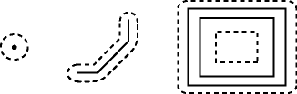
Operatora SDO_WITHIN_DISTANCE izmantošanas piemēri
1. Vaicājums atlasa ģeometrijas no tabulas Slanis_1, kuras atrodas attālumā 10 no mainīgajā (aGeometr) norādītās ģeometrijas.
SELECT A.NUM FROM Slanis_1 A
WHERE
SDO_WITHIN_DISTANCE(A.Geometrija_1, :aGeometr, 'distance = 10') = 'TRUE';
2. Vaicājums atlasa ģeometrijas no tabulas Slanis_1, kuras atrodas attālumā 10 no norādītās ģeometrijas.
SELECT A.NUM FROM Slanis_1 A
WHERE
SDO_WITHIN_DISTANCE(A.Geometry, sdo_geometry(2003,NULL,NULL,
sdo_elem_info_array(1,1003,3), sdo_ordinate_array(x1,y1,x2,y2)),
'distance = 10') = 'TRUE';

3. Vaicājums atlasa ģeometrijas no tabulas Slanis_1, kuras atrodas attālumā 10 no tabulā Slanis_2 norādītās ģeometrijas (Slanis_2.NUM =1) .
SELECT A.NUM FROM Slanis_1 A, Slanis_2 B
WHERE B.NUM = 1 AND
SDO_WITHIN_DISTANCE(A.Geometrija_1, B.Geometrija_2, 'distance = 10') = 'TRUE';

Operatora SDO_JOIN izmantošana

SDO_JOIN (Tabula_1, Kolona_G1, Tabula_2, Kolona_G2, operatora_parametri, saglabat_savien_kartibu) RETURN SDO_ROWIDSET;

SDO_JOIN parametri | Apraksts
Tabula_ | Name of the first table to be used in the spatial join operation. The table must have a column of type SDO_GEOMETRY. Data type is VARCHAR2.
Kolona_G1 | Name of the spatial column of type SDO_GEOMETRY in Tabula_1. A spatial R-tree index must be defined on this column. Data type is VARCHAR2.
Tabula_2 | Name of the second table to be used in the spatial join operation. (It can be the same as or different from Tabula_1.) Data type is VARCHAR2.
Kolona_G2 | Name of the spatial column of type SDO_GEOMETRY in Tabula_2. A spatial R-tree index must be defined on this column. Data type is VARCHAR2.
Operatora_  parametri | Optional parameter string of keywords and values; available only if mask=ANYINTERACT. Determines the behavior of the operator. Data type is VARCHAR2. Default is NULL.
 | mask | The topological relationship of interest.Valid values are 'mask=<value>' where <value> is one or more of the mask values valid for the SDO_RELATE operator (TOUCH, CONTAINS, OVERLAPBDYDISJOINT, OVERLAPBDYINTERSECT, EQUAL, INSIDE, COVEREDBY, COVERS, ANYINTERACT, ON), or FILTER, which checks if the MBRs (the filter-level approximations) intersect. Multiple masks are combined with the logical Boolean operator OR (for example, 'mask=inside+touch'); however, FILTER cannot be combined with any other mask. If this parameter is null or contains an empty string, mask=FILTER is assumed.
 | distance | Specifies a numeric distance value that is added to the tolerance value before the relationship checks are performed. For example, if the tolerance is 10 meters and you specify 'distance=100 unit=meter', two objects are considered to have spatial interaction if they are within 110 meters of each other.If you specify distance but not unit, the unit of measurement associated with the data is assumed.
 | unit | Specifies a unit of measurement to be associated with the distance value (for example, 'distance=100 unit=meter'If you specify unit, you must also specify distance.Data type is VARCHAR2. Default = unit of measurement associated with the data. For geodetic data, the default is meters.
saglabat_  savien_kartibu | Optional parameter to specify if the join order is guaranteed to be preserved during processing of the operator. If the value is 0 (the default), the order of the tables might be changed; if the value is 1, the order of the tables is not changed. Data type is NUMBER. Default is 0.

Operatora SDO_JOIN rezultāta struktūra

SDO_JOIN atgriež SDO_ROWIDSET tipa objektu, kurš ir iekļauta tabula ar SDO_ROWIDPAIR tipa objektiem. Šo objektu tipu definējumi ir sekojoši:

CREATE TYPE sdo_rowidset as TABLE OF sdo_rowidpair;

CREATE TYPE sdo_rowidpair AS OBJECT
(rowid1 VARCHAR2(24),
rowid2 VARCHAR2(24));

SDO_JOIN is technically not an operator, but a table function. This function is recommended when you need to perform full table joins.
SDO_JOIN operatora izmantošanas piemērs

Piemērā tabula Slanis_1 tiek savienota pati ar sevi un katrai ģeometrijai tiek noskaidrotas ģeometrijas, kurām ar to ir telpiska saistība.
ROWID1 un ROWID2 apzīmējumi nāk no SDO_ROWIDPAIR tipa definējuma.

SELECT A.NOS, B.NOS FROM Slanis_1 A, Slanis_1 B,
TABLE(SDO_JOIN('Slanis_1, 'GEOMETR', 'Slanis_1, 'GEOMETR',
'mask=ANYINTERACT')) C
WHERE c.rowid1 = a.NUM AND c.rowid2 = b.NUM ORDER BY A.NOS;

A.NOS B.NOS
--------------------------------------------------
geometr_a geometr_a
geometr_a geometr_b
geometr_a geometr_c
geometr_b geometr_a
geometr_b geometr_b
geometr_b geometr_c
geometr_c geometr_a
geometr_c geometr_b
geometr_c geometr_c
geometr_d geometr_d

10 rows selected.

SDO_ANYINTERACT
SDO_ANYINTERACT(geometry1, geometry2);
Checks if any geometries in a table have the ANYINTERACT topological relationship with a specified geometry. Equivalent to specifying the SDO_RELATE operator with 'mask=ANYINTERACT'.
Value | Description
geometry1 | Specifies a geometry column in a table. The column must be spatially indexed.  Data type is SDO_GEOMETRY.
geometry2 | Specifies either a geometry from a table or a transient instance of a geometry. (Specified using a bind variable or SDO_GEOMETRY constructor.)  Data type is SDO_GEOMETRY.

The expression SDO_ANYINTERACT(geometry1,geometry2) = 'TRUE' evaluates to TRUE for object pairs that have the ANYINTERACT topological relationship, and FALSE otherwise.
For an explanation of the topological relationships and the nine-intersection model used by Spatial, see Section 1.8.
Examples
The following example finds geometries that have the ANYINTERACT relationship with a query window (here, a rectangle with lower-left, upper-right coordinates 4,6, 8,8). (The example uses the definitions and data described in Section 2.1 and illustrated in Figure 2-1.)
SELECT c.mkt_id, c.name
FROM cola_markets c
WHERE SDO_ANYINTERACT(c.shape,
SDO_GEOMETRY(2003, NULL, NULL,
SDO_ELEM_INFO_ARRAY(1,1003,3),
SDO_ORDINATE_ARRAY(4,6, 8,8))
) = 'TRUE';

MKT_ID NAME
---------- --------------------------------
2 cola_b
1 cola_a
4 cola_d

SDO_CONTAINS
SDO_CONTAINS(geometry1, geometry2);
Checks if any geometries in a table have the CONTAINS topological relationship with a specified geometry. Equivalent to specifying the SDO_RELATE operator with 'mask=CONTAINS'.
Value | Description
geometry1 | Specifies a geometry column in a table. The column must be spatially indexed.  Data type is SDO_GEOMETRY.
geometry2 | Specifies either a geometry from a table or a transient instance of a geometry. (Specified using a bind variable or SDO_GEOMETRY constructor.)  Data type is SDO_GEOMETRY.

The expression SDO_CONTAINS(geometry1,geometry2) = 'TRUE' evaluates to TRUE for object pairs that have the CONTAINS topological relationship, and FALSE otherwise.
See the Usage Notes for the SDO_RELATE operator in this chapter.
For an explanation of the topological relationships and the nine-intersection model used by Spatial, see Section 1.8.
Examples
The following example finds geometries that have the CONTAINS relationship with a query window (here, a rectangle with lower-left, upper-right coordinates 2,2, 4,6). (The example uses the definitions and data described in Section 2.1 and illustrated in Figure 2-1.) In this example, only cola_a contains the query window geometry.
SELECT c.mkt_id, c.name
FROM cola_markets c
WHERE SDO_CONTAINS(c.shape,
SDO_GEOMETRY(2003, NULL, NULL,
SDO_ELEM_INFO_ARRAY(1,1003,3),
SDO_ORDINATE_ARRAY(2,2, 4,6))
) = 'TRUE';

MKT_ID NAME
---------- --------------------------------
1 cola_a

SDO_COVEREDBY
SDO_COVEREDBY(geometry1, geometry2);
Checks if any geometries in a table have the COVEREDBY topological relationship with a specified geometry. Equivalent to specifying the SDO_RELATE operator with 'mask=COVEREDBY'.
Value | Description
geometry1 | Specifies a geometry column in a table. The column must be spatially indexed.  Data type is SDO_GEOMETRY.
geometry2 | Specifies either a geometry from a table or a transient instance of a geometry. (Specified using a bind variable or SDO_GEOMETRY constructor.)  Data type is SDO_GEOMETRY.

The expression SDO_COVEREDBY(geometry1,geometry2) = 'TRUE' evaluates to TRUE for object pairs that have the COVEREDBY topological relationship, and FALSE otherwise.
For an explanation of the topological relationships and the nine-intersection model used by Spatial, see Section 1.8.
Examples
The following example finds geometries that have the COVEREDBY relationship with a query window (here, a rectangle with lower-left, upper-right coordinates 1,1, 5,8). (The example uses the definitions and data described in Section 2.1 and illustrated in Figure 2-1.) In this example, only cola_a is covered by the query window geometry.
SELECT c.mkt_id, c.name
FROM cola_markets c
WHERE SDO_COVEREDBY(c.shape,
SDO_GEOMETRY(2003, NULL, NULL,
SDO_ELEM_INFO_ARRAY(1,1003,3),
SDO_ORDINATE_ARRAY(1,1, 5,8))
) = 'TRUE';

MKT_ID NAME
---------- --------------------------------
1 cola_a

SDO_COVERS
SDO_COVERS(geometry1, geometry2);
Checks if any geometries in a table have the COVERS topological relationship with a specified geometry. Equivalent to specifying the SDO_RELATE operator with 'mask=COVERS'.
Value | Description
geometry1 | Specifies a geometry column in a table. The column must be spatially indexed.  Data type is SDO_GEOMETRY.
geometry2 | Specifies either a geometry from a table or a transient instance of a geometry. (Specified using a bind variable or SDO_GEOMETRY constructor.)  Data type is SDO_GEOMETRY.

The expression SDO_COVERS(geometry1,geometry2) = 'TRUE' evaluates to TRUE for object pairs that have the COVERS topological relationship, and FALSE otherwise.
For an explanation of the topological relationships and the nine-intersection model used by Spatial, see Section 1.8.
Examples
The following example finds geometries that have the COVERS relationship with a query window (here, a rectangle with lower-left, upper-right coordinates 1,1, 4,6). (The example uses the definitions and data described in Section 2.1 and illustrated in Figure 2-1.) In this example, only cola_a covers the query window geometry.
SELECT c.mkt_id, c.name
FROM cola_markets c
WHERE SDO_COVERS(c.shape,
SDO_GEOMETRY(2003, NULL, NULL,
SDO_ELEM_INFO_ARRAY(1,1003,3),
SDO_ORDINATE_ARRAY(1,1, 4,6))
) = 'TRUE';

MKT_ID NAME
---------- --------------------------------
1 cola_a

SDO_EQUAL
SDO_EQUAL(geometry1, geometry2);
Checks if any geometries in a table have the EQUAL topological relationship with a specified geometry. Equivalent to specifying the SDO_RELATE operator with 'mask=EQUAL'.
Value | Description
geometry1 | Specifies a geometry column in a table. The column must be spatially indexed.  Data type is SDO_GEOMETRY.
geometry2 | Specifies either a geometry from a table or a transient instance of a geometry. (Specified using a bind variable or SDO_GEOMETRY constructor.)  Data type is SDO_GEOMETRY.

The expression SDO_EQUAL(geometry1,geometry2) = 'TRUE' evaluates to TRUE for object pairs that have the EQUAL topological relationship, and FALSE otherwise.
For an explanation of the topological relationships and the nine-intersection model used by Spatial, see Section 1.8.
Examples
The following example finds geometries that have the EQUAL relationship with a query window (here, a rectangle with lower-left, upper-right coordinates 1,1, 5,7). (The example uses the definitions and data described in Section 2.1 and illustrated in Figure 2-1.) In this example, cola_a (and only cola_a) has the same boundary and interior as the query window geometry.
SELECT c.mkt_id, c.name
FROM cola_markets c
WHERE SDO_EQUAL(c.shape,
SDO_GEOMETRY(2003, NULL, NULL,
SDO_ELEM_INFO_ARRAY(1,1003,3),
SDO_ORDINATE_ARRAY(1,1, 5,7))
) = 'TRUE';

MKT_ID NAME
---------- --------------------------------
1 cola_a

SDO_INSIDE
SDO_INSIDE(geometry1, geometry2);
Checks if any geometries in a table have the INSIDE topological relationship with a specified geometry. Equivalent to specifying the SDO_RELATE operator with 'mask=INSIDE'.
Value | Description
geometry1 | Specifies a geometry column in a table. The column must be spatially indexed.  Data type is SDO_GEOMETRY.
geometry2 | Specifies either a geometry from a table or a transient instance of a geometry. (Specified using a bind variable or SDO_GEOMETRY constructor.)  Data type is SDO_GEOMETRY.

The expression SDO_INSIDE(geometry1,geometry2) = 'TRUE' evaluates to TRUE for object pairs that have the INSIDE topological relationship, and FALSE otherwise.
For an explanation of the topological relationships and the nine-intersection model used by Spatial, see Section 1.8.
Examples
The following example finds geometries that have the INSIDE relationship with a query window (here, a rectangle with lower-left, upper-right coordinates 5,6, 12,12). (The example uses the definitions and data described in Section 2.1 and illustrated in Figure 2-1.) In this example, only cola_d (the circle) is inside the query window geometry.
SELECT c.mkt_id, c.name
FROM cola_markets c
WHERE SDO_INSIDE(c.shape,
SDO_GEOMETRY(2003, NULL, NULL,
SDO_ELEM_INFO_ARRAY(1,1003,3),
SDO_ORDINATE_ARRAY(5,6, 12,12))
) = 'TRUE';

MKT_ID NAME
---------- --------------------------------
4 cola_d

SDO_NN
SDO_NN(geometry1, geometry2, param [, number]);
Uses the spatial index to identify the nearest neighbors for a geometry.
Value | Description
geometry1 | Specifies a geometry column in a table. The column must be spatially indexed.  Data type is SDO_GEOMETRY.
geometry2 | Specifies either a geometry from a table or a transient instance of a geometry. The nearest neighbor or neighbors to geometry2 will be returned from geometry1. (geometry2 is specified using a bind variable or SDO_GEOMETRY constructor.)  Data type is SDO_GEOMETRY.
param | Determines the behavior of the operator. The available keywords are listed in Table 12-4. If you do not specify this parameter, the operator returns all rows in increasing distance order from geometry2.  Data type is VARCHAR2.
number | If the SDO_NN_DISTANCE ancillary operator is included in the call to SDO_NN, specifies the same number used in the call to SDO_NN_DISTANCE.  Data type is NUMBER.

Keywords for the SDO_NN Param Parameter
Keyword | Description
sdo_batch_size | Specifies the number of rows to be evaluated at a time when the SDO_NN expression may need to be evaluated multiple times in order to return the desired number of results that satisfy the WHERE clause. Available only when an R-tree index is used. If you specify sdo_batch_size=0 (or if you omit the param parameter completely), Spatial calculates a batch size suited to the result set size. See the Usage Notes and Examples for more information.  Data type is NUMBER.  For example: 'sdo_batch_size=10'
sdo_num_res | If sdo_batch_size is not specified, specifies the number of results (nearest neighbors) to be returned. If sdo_batch_size is specified, this keyword is ignored; instead, use the ROWNUM pseudocolumn to limit the number of results. See the Usage Notes and Examples for more information.  Data type is NUMBER. Default = 1.  For example: 'sdo_num_res=5'
unit | If the SDO_NN_DISTANCE ancillary operator is included in the call to SDO_NN, specifies the unit of measurement: a quoted string with unit= and an SDO_UNIT value from the MDSYS.SDO_DIST_UNITS table. See Section 2.6 for more information about unit of measurement specification.  Data type is VARCHAR2. Default = unit of measurement associated with the data. For geodetic data, the default is meters.  For example: 'unit=KM'

This operator returns the sdo_num_res number of objects from geometry1 that are nearest to geometry2 in the query. In determining how near two geometry objects are, the shortest possible distance between any two points on the surface of each object is used.
The operator is disabled if the table does not have a spatial index or if the index has been built on more than two dimensions.
The operator must always be used in a WHERE clause, and the condition that includes the operator should be an expression of the form SDO_NN(arg1, arg2, '<some_parameter>') = 'TRUE'.
The operator can be used in two ways:
- If all geometries in the layer are candidates, use the sdo_num_res keyword to specify the number of geometries returned.
- If any geometries in the table might be nearer than the geometries specified in the WHERE clause, use the sdo_batch_size keyword and use the WHERE clause (including the ROWNUM pseudocolumn) to limit the number of geometries returned.
Specify the sdo_batch_size keyword if any geometries in the table might be nearer than the geometries specified in the WHERE clause. For example, assume that a RESTAURANTS table contains different types of restaurants, and you want to find the two nearest Italian restaurants to your hotel. The query might look like the following:
SELECT r.name FROM restaurants r WHERE
SDO_NN(r.geometry, :my_hotel, 'sdo_batch_size=10') = 'TRUE'
AND r.cuisine = 'Italian' AND ROWNUM <=2;

If the sdo_batch_size keyword is not specified in this example, only the two nearest restaurants are returned, regardless of their CUISINE value; and if the CUISINE value of these two rows is not Italian, the query may return no rows. The ROWNUM <=2 clause is necessary to limit the number of results returned to no more than 2 where CUISINE is Italian.
The sdo_batch_size value can affect the performance of nearest neighbor queries. A good general guideline is to specify the number of candidate rows likely to satisfy the WHERE clause. Using the preceding example of a query for Italian restaurants, if approximately 20 percent of the restaurants nearest to the hotel are Italian and if you want 2 restaurants, an sdo_batch_size value of 10 will probably result in the best performance. On the other hand, if only approximately 5 percent of the restaurants nearest to the hotel are Italian and if you want 2 restaurants, an sdo_batch_size value of 40 would be better.
You can specify sdo_batch_size=0, which causes Spatial to calculate a batch size that is suitable for the result set size. However, the calculated batch size may not be optimal, and the calculation incurs some processing overhead; if you can determine a good sdo_batch_size value for a query, the performance will probably be better than if you specify sdo_batch_size=0.
If the sdo_batch_size keyword is specified, any sdo_num_res value is ignored. Do not specify both keywords.
Specify the number parameter only if you are using the SDO_NN_DISTANCE ancillary operator in the call to SDO_NN. See the information about the SDO_NN_DISTANCE operator in this chapter.
If this operator is used with geodetic data, the data must be indexed with an R-tree spatial index. If this operator is used with geodetic data and if the R-tree spatial index is created with 'geodetic=false' specified, you cannot use the unit parameter.
If two or more objects from geometry1 are an equal distance from geometry2, any of the objects can be returned on any call to the function. For example, if item_a, item_b, and item_c are nearest to and equally distant from geometry2, and if SDO_NUM_RES=2, two of those three objects are returned, but they can be any two of the three.
If the SDO_NN operator uses a partitioned spatial index (see Section 4.1.6), the requested number of geometries is returned for each partition that contains candidate rows based on the query criteria. For example, if you request the 5 nearest restaurants to a point and the spatial index has 4 partitions, the operator returns up to 20 (5*4) geometries. In this case, you must use the ROWNUM pseudocolumn (here, WHERE ROWNUM <=5) to return the 5 nearest restaurants.
If geometry1 and geometry2 are based on different coordinate systems, geometry2 is temporarily transformed to the coordinate system of geometry1 for the operation to be performed, as described in Section 6.7.1.
SDO_NN is not supported for spatial joins.
In some situations the SDO_NN operator will not use the spatial index unless an optimizer hint forces the index to be used. This can occur when a query involves a join; and if the optimizer hint is not used in such situations, an internal error occurs. To prevent such errors, you should always specify an optimizer hint to use the spatial index with the SDO_NN operator, regardless of how simple or complex the query is. For example, the following excerpt from a query specifies to use the COLA_SPATIAL_IDX index that is defined on the COLA_MARKETS table:
SELECT /*+ INDEX(c cola_spatial_idx) */
c.mkt_id, c.name, ... FROM cola_markets c, ...;

However, if there is an index associated with the column predicate in the WHERE clause, be sure that this index is not used by specifying the NO_INDEX hint for that index. For example, if there was an index named COLA_NAME_IDX defined on the NAME column, you would need to specify the hints in the preceding example as follows:
SELECT /*+ INDEX(c cola_spatial_idx) NO_INDEX(c cola_name_idx) */
c.mkt_id, c.name, ... FROM cola_markets c, ...;

(Note, however, that there is no index named COLA_NAME_IDX in the example in Section 2.1.)
For detailed information about using optimizer hints, see Oracle Database Performance Tuning Guide.
Examples
The following example finds the two objects from the SHAPE column in the COLA_MARKETS table that are nearest to a specified point (10,7). (The example uses the definitions and data from Section 2.1.)
SELECT /*+ INDEX(c cola_spatial_idx) */
c.mkt_id, c.name FROM cola_markets c WHERE SDO_NN(c.shape,
sdo_geometry(2001, NULL, sdo_point_type(10,7,NULL), NULL,
NULL), 'sdo_num_res=2') = 'TRUE';

MKT_ID NAME
---------- --------------------------------
2 cola_b
4 cola_d

The following example uses the sdo_batch_size keyword to find the two objects (ROWNUM <=2), with a NAME value less than 'cola_d', from the SHAPE column in the COLA_MARKETS table that are nearest to a specified point (10,7). The value of 3 for sdo_batch_size represents a best guess at the number of nearest geometries that need to be evaluated before the WHERE clause condition is satisfied. (The example uses the definitions and data from Section 2.1.)
SELECT /*+ INDEX(c cola_spatial_idx) */ c.mkt_id, c.name
FROM cola_markets c
WHERE SDO_NN(c.shape, sdo_geometry(2001, NULL,
sdo_point_type(10,7,NULL), NULL, NULL),
'sdo_batch_size=3') = 'TRUE'
AND c.name < 'cola_d' AND ROWNUM <= 2;

MKT_ID NAME
---------- --------------------------------
2 cola_b
3 cola_c

SDO_NN_DISTANCE
SDO_NN_DISTANCE(number);
Returns the distance of an object returned by the SDO_NN operator. Valid only within a call to the SDO_NN operator.
Value | Description
number | Specifies a number that must be the same as the last parameter passed to the SDO_NN operator.  Data type is NUMBER.

This operator returns the distance of an object returned by the SDO_NN operator. In determining how near two geometry objects are, the shortest possible distance between any two points on the surface of each object is used.
SDO_NN_DISTANCE is an ancillary operator to the SDO_NN operator. It returns the distance between the specified geometry and a nearest neighbor object. This distance is passed as ancillary data to the SDO_NN operator. (For an explanation of how operators can use ancillary data, see the section on ancillary data in the chapter on domain indexes in Oracle Data Cartridge Developer's Guide.)
You can choose any arbitrary number for the number parameter. The only requirement is that it must match the last parameter in the call to the SDO_NN operator.
Use a bind variable to store and operate on the distance value.
Examples
The following example finds the two objects from the SHAPE column in the COLA_MARKETS table that are nearest to a specified point (10,7), and it finds the distance between each object and the point. (The example uses the definitions and data from Section 2.1.)
SELECT /*+ INDEX(c cola_spatial_idx) */
c.mkt_id, c.name, SDO_NN_DISTANCE(1) dist
FROM cola_markets c
WHERE SDO_NN(c.shape, sdo_geometry(2001, NULL,
sdo_point_type(10,7,NULL), NULL, NULL),
'sdo_num_res=2', 1) = 'TRUE' ORDER BY dist;

MKT_ID NAME DIST
---------- -------------------------------- ----------
4 cola_d .828427125
2 cola_b 2.23606798

Note the following about this example:
- 1 is used as the number parameter for SDO_NN_DISTANCE, and 1 is also specified as the last parameter to SDO_NN (after 'sdo_num_res=2').
- The column alias dist holds the distance between the object and the point. (For geodetic data, the distance unit is meters; for non-geodetic data, the distance unit is the unit associated with the data.)

SDO_ON
SDO_ON(geometry1, geometry2);
Checks if any geometries in a table have the ON topological relationship with a specified geometry. Equivalent to specifying the SDO_RELATE operator with 'mask=ON'.
Value | Description
geometry1 | Specifies a geometry column in a table. The column must be spatially indexed.  Data type is SDO_GEOMETRY.
geometry2 | Specifies either a geometry from a table or a transient instance of a geometry. (Specified using a bind variable or SDO_GEOMETRY constructor.)  Data type is SDO_GEOMETRY.

The expression SDO_ON(geometry1,geometry2) = 'TRUE' evaluates to TRUE for object pairs that have the ON topological relationship, and FALSE otherwise.
For an explanation of the topological relationships and the nine-intersection model used by Spatial, see Section 1.8.
Examples
The following example finds geometries that have the ON relationship with a query window (here, a rectangle with lower-left, upper-right coordinates 4,6, 8,8). (The example uses the definitions and data described in Section 2.1 and illustrated in Figure 2-1.) This example returns no rows because there are no line string geometries in the SHAPE column.
SELECT c.mkt_id, c.name
FROM cola_markets c
WHERE SDO_ON(c.shape,
SDO_GEOMETRY(2003, NULL, NULL,
SDO_ELEM_INFO_ARRAY(1,1003,3),
SDO_ORDINATE_ARRAY(4,6, 8,8))
) = 'TRUE';

no rows selected

SDO_OVERLAPBDYDISJOINT
SDO_OVERLAPBDYDISJOINT(geometry1, geometry2);
Checks if any geometries in a table have the OVERLAPBDYDISJOINT topological relationship with a specified geometry. Equivalent to specifying the SDO_RELATE operator with 'mask=OVERLAPBDYDISJOINT'.
See the section on the SDO_RELATE operator in this chapter for information about the operations performed by this operator and for usage requirements.
Value | Description
geometry1 | Specifies a geometry column in a table. The column must be spatially indexed.  Data type is SDO_GEOMETRY.
geometry2 | Specifies either a geometry from a table or a transient instance of a geometry. (Specified using a bind variable or SDO_GEOMETRY constructor.)  Data type is SDO_GEOMETRY.

The expression SDO_OVERLAPBDYDISJOINT(geometry1,geometry2) = 'TRUE' evaluates to TRUE for object pairs that have the OVERLAPBDYDISJOINT topological relationship, and FALSE otherwise.
For an explanation of the topological relationships and the nine-intersection model used by Spatial, see Section 1.8.
Examples
The following example finds geometries that have the OVERLAPBDYDISJOINT relationship with a line string geometry (here, a horizontal line from 0,6 to 2,6). (The example uses the definitions and data described in Section 2.1 and illustrated in Figure 2-1.) In this example, only cola_a has the OVERLAPBDYDISJOINT relationship with the line string geometry.
SELECT c.mkt_id, c.name
FROM cola_markets c
WHERE SDO_OVERLAPBDYDISJOINT(c.shape,
SDO_GEOMETRY(2002, NULL, NULL,
SDO_ELEM_INFO_ARRAY(1,2,1),
SDO_ORDINATE_ARRAY(0,6, 2,6))
) = 'TRUE';

MKT_ID NAME
---------- --------------------------------
1 cola_a

SDO_OVERLAPBDYINTERSECT
SDO_OVERLAPBDYINTERSECT(geometry1, geometry2);
Checks if any geometries in a table have the OVERLAPBDYINTERSECT topological relationship with a specified geometry. Equivalent to specifying the SDO_RELATE operator with 'mask=OVERLAPBDYINTERSECT'.
Value | Description
geometry1 | Specifies a geometry column in a table. The column must be spatially indexed.  Data type is SDO_GEOMETRY.
geometry2 | Specifies either a geometry from a table or a transient instance of a geometry. (Specified using a bind variable or SDO_GEOMETRY constructor.)  Data type is SDO_GEOMETRY.

The expression SDO_OVERLAPBDYINTERSECT(geometry1,geometry2) = 'TRUE' evaluates to TRUE for object pairs that have the OVERLAPBDYINTERSECT topological relationship, and FALSE otherwise.
For an explanation of the topological relationships and the nine-intersection model used by Spatial, see Section 1.8.
Examples
The following example finds geometries that have the OVERLAPBDYINTERSECT relationship with a query window (here, a rectangle with lower-left, upper-right coordinates 4,6, 8,8). (The example uses the definitions and data described in Section 2.1 and illustrated in Figure 2-1.) In this example, cola_a, cola_b, and cola_d have the OVERLAPBDYINTERSECT relationship with the query window geometry.
SELECT c.mkt_id, c.name
FROM cola_markets c
WHERE SDO_OVERLAPBDYINTERSECT(c.shape,
SDO_GEOMETRY(2003, NULL, NULL,
SDO_ELEM_INFO_ARRAY(1,1003,3),
SDO_ORDINATE_ARRAY(4,6, 8,8))
) = 'TRUE';

MKT_ID NAME
---------- --------------------------------
2 cola_b
1 cola_a
4 cola_d

SDO_OVERLAPS
SDO_OVERLAPS(geometry1, geometry2);
Checks if any geometries in a table overlap (that is, have the OVERLAPBDYDISJOINT or OVERLAPBDYINTERSECT topological relationship with) a specified geometry. Equivalent to specifying the SDO_RELATE operator with 'mask=OVERLAPBDYDISJOINT+OVERLAPBDYINTERSECT'.
Value | Description
geometry1 | Specifies a geometry column in a table. The column must be spatially indexed.  Data type is SDO_GEOMETRY.
geometry2 | Specifies either a geometry from a table or a transient instance of a geometry. (Specified using a bind variable or SDO_GEOMETRY constructor.)  Data type is SDO_GEOMETRY.

The expression SDO_OVERLAPS(geometry1,geometry2) = 'TRUE' evaluates to TRUE for object pairs that have the OVERLAPBDYDISJOINT or OVERLAPBDYINTERSECT topological relationship, and FALSE otherwise.
For an explanation of the topological relationships and the nine-intersection model used by Spatial, see Section 1.8.
Examples
The following example finds geometries that overlap a query window (here, a rectangle with lower-left, upper-right coordinates 4,6, 8,8). (The example uses the definitions and data described in Section 2.1 and illustrated in Figure 2-1.) In this example, three of the geometries in the SHAPE column overlap the query window geometry.
SELECT c.mkt_id, c.name
FROM cola_markets c
WHERE SDO_OVERLAPS(c.shape,
SDO_GEOMETRY(2003, NULL, NULL,
SDO_ELEM_INFO_ARRAY(1,1003,3),
SDO_ORDINATE_ARRAY(4,6, 8,8))
) = 'TRUE';

MKT_ID NAME
---------- --------------------------------
2 cola_b
1 cola_a
4 cola_d

SDO_TOUCH
SDO_TOUCH(geometry1, geometry2);
Checks if any geometries in a table have the TOUCH topological relationship with a specified geometry. Equivalent to specifying the SDO_RELATE operator with 'mask=TOUCH'.
Value | Description
geometry1 | Specifies a geometry column in a table. The column must be spatially indexed.  Data type is SDO_GEOMETRY.
geometry2 | Specifies either a geometry from a table or a transient instance of a geometry. (Specified using a bind variable or SDO_GEOMETRY constructor.)  Data type is SDO_GEOMETRY.

The expression SDO_TOUCH(geometry1,geometry2) = 'TRUE' evaluates to TRUE for object pairs that have the TOUCH topological relationship, and FALSE otherwise.
For an explanation of the topological relationships and the nine-intersection model used by Spatial, see Section 1.8.
Examples
The following example finds geometries that have the TOUCH relationship with a query window (here, a rectangle with lower-left, upper-right coordinates 1,1, 5,7). (The example uses the definitions and data described in Section 2.1 and illustrated in Figure 2-1.) In this example, only cola_b has the TOUCH relationship with the query window geometry.
SELECT c.mkt_id, c.name
FROM cola_markets c
WHERE SDO_TOUCH(c.shape,
SDO_GEOMETRY(2003, NULL, NULL,
SDO_ELEM_INFO_ARRAY(1,1003,3),
SDO_ORDINATE_ARRAY(1,1, 5,7))
) = 'TRUE';
FROM cola_markets c

MKT_ID NAME
---------- --------------------------------
2 cola_b

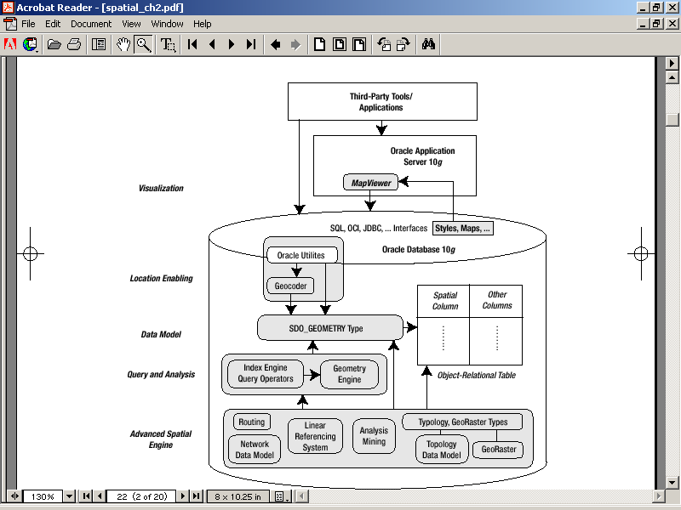

Oracle Spatial arhitektūra



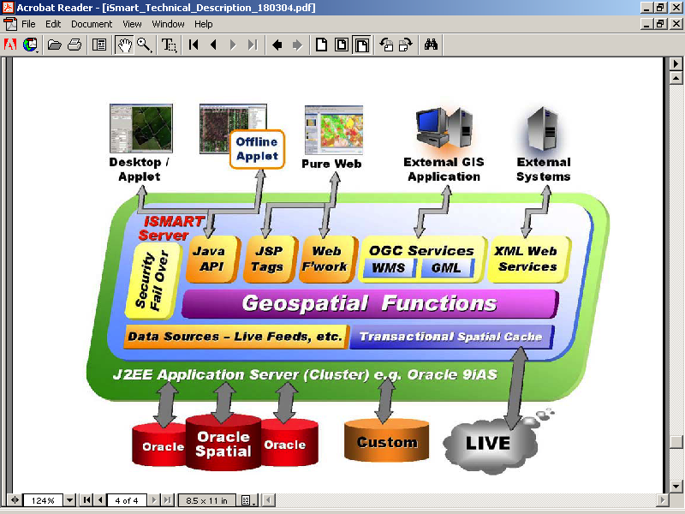

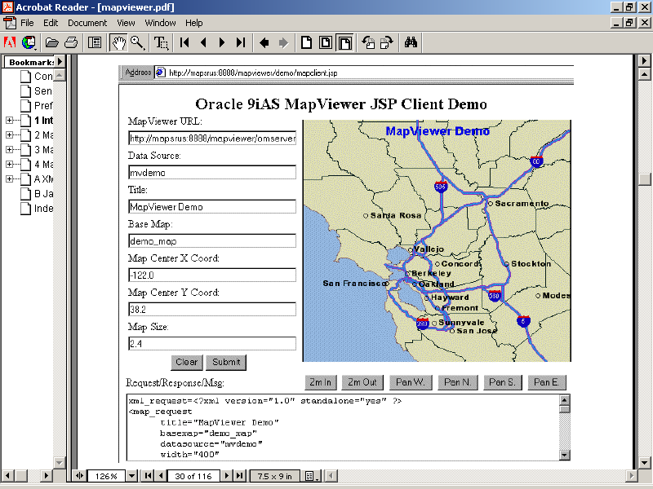

Studenta veidota vizualizācijas sistēma

